**NAME : VIKAS YADAV**

**CONTACT: 7045747742**

**TrainerTime Hub**

**Objective**: Your task is to create the front-end part of a web application that allows a fitness trainer to efficiently manage appointments for clients. The website should provide a user-friendly interface for the trainer to add, edit, and delete appointments, along with client details. Additionally, as a bonus (optional), implement a calendar view page in order for the fitness trainer to see all of her/his appointments.

**About TrainerTime Hub :-** TrainerTime Hub is a appointment scheduling app made for trainers to schedule their weekly appointment schedule of their client. Trainer can see their scheduled appointment in the calendar marked in “Light Blue” colour and also can “Edit” and “Delete” their scheduled appointment as per requirement. This application makes them easy to manage their appointment seamleselly.

**REQUIREMENTS FULLFILLMENT AND WORKFLOW OF APPLICATION:-**

1. **User Interface (UI) :-** This project is build using react.js and to store data we have used application local storage .

The below UI represents calendar where trainer can see booked slots of clients where booked slots are displayed in light blue colour and when trainer select that date then booked slots will be displayed

By clicking on that particular slot trainer can view the client details.

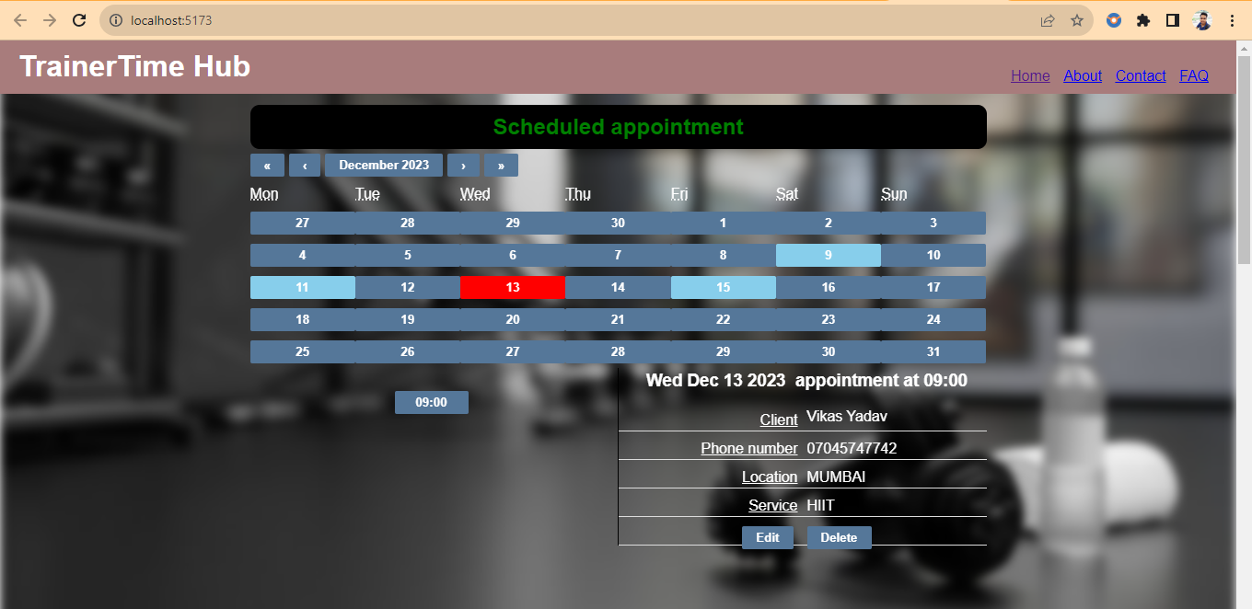

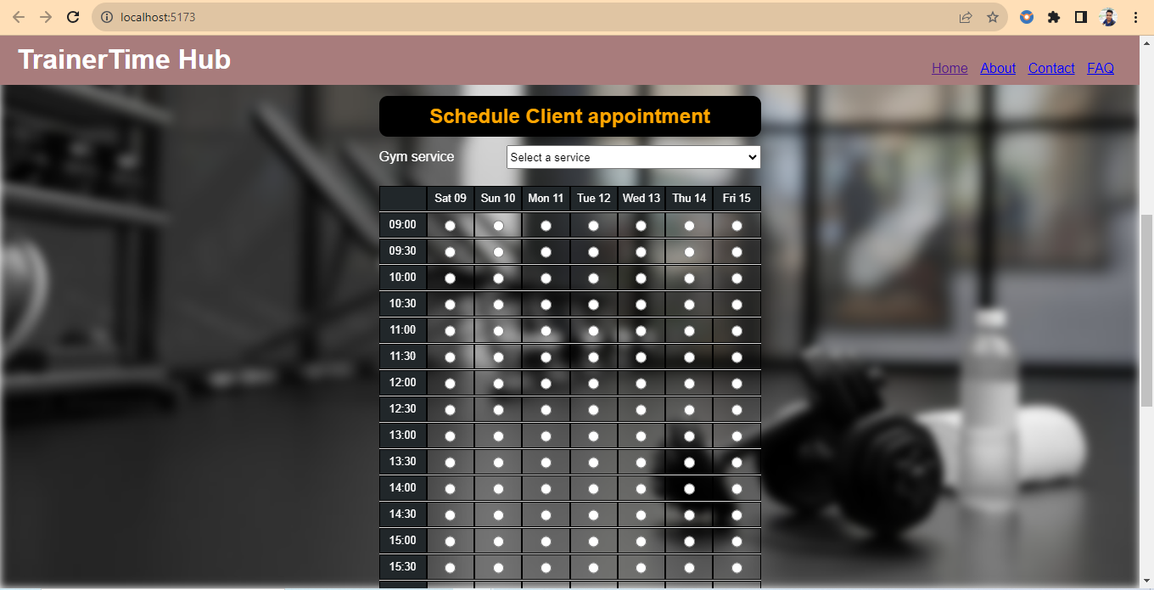

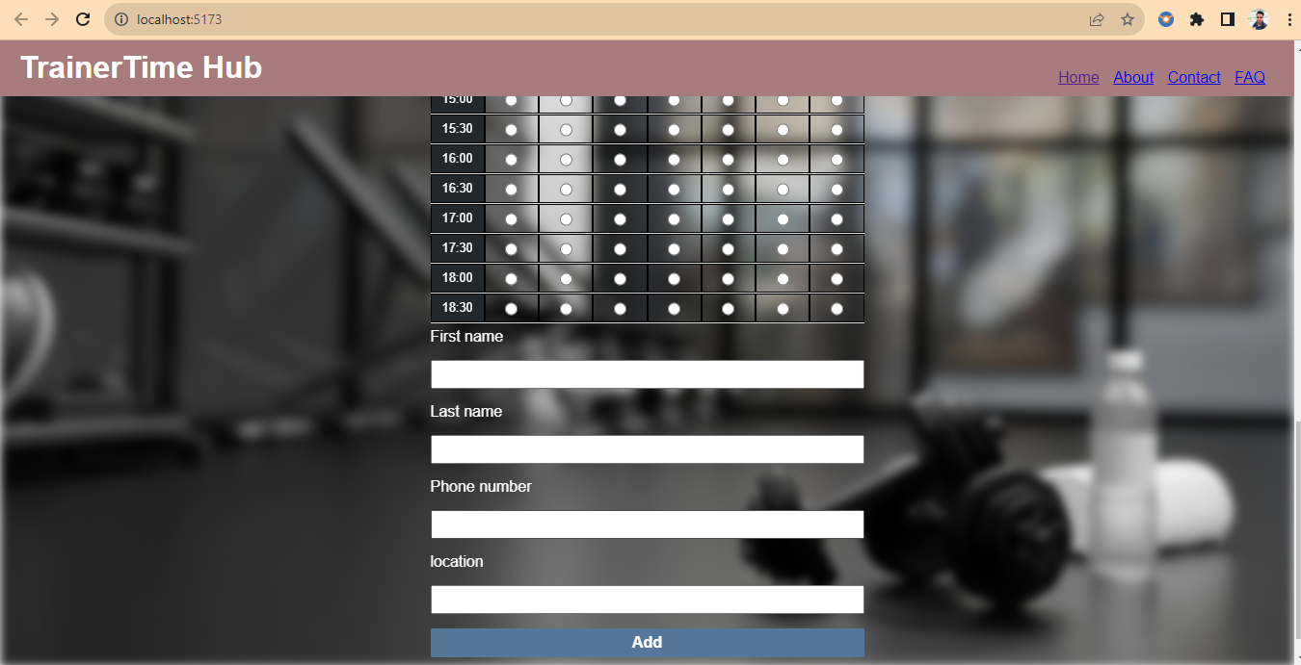

1. **Adding Appointments**:

To schedule appointmenttrainer can book the slot by filling the required details.

Step 1:- select the service from gym service dropdown list.

Step 2:- select the date and time radio button .

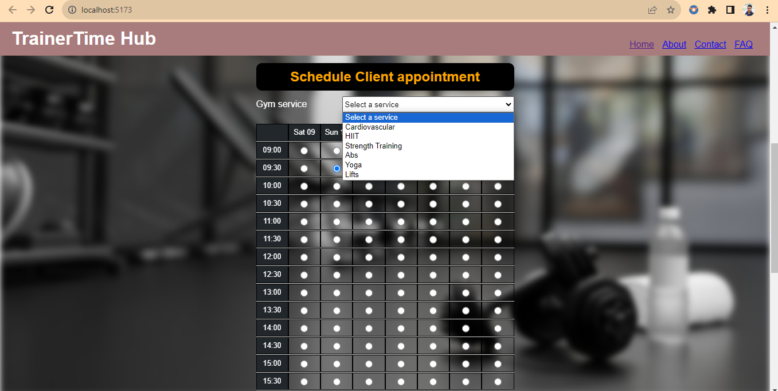

Step 3:- now fill the client data in textbox and provide details as mentioned and click on “**Add**” button to add a slot.

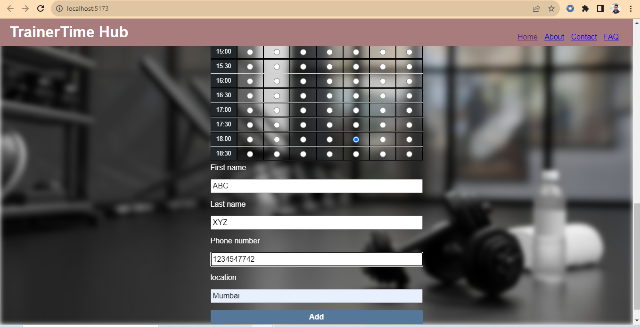

Step 4:- now trainer will be able to see the booked slot in calendar dashboard.

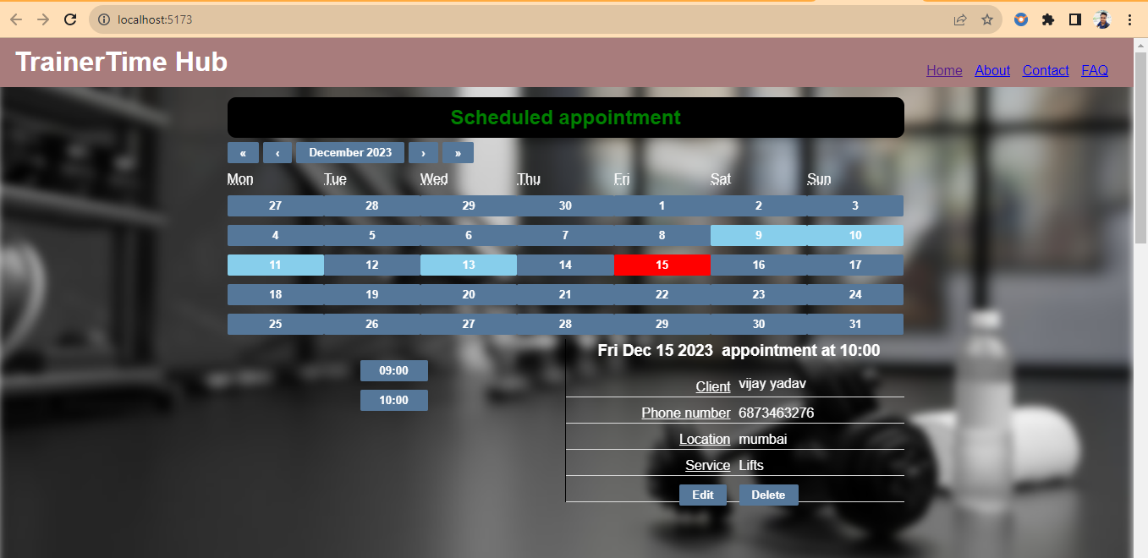

1. **Editing Appointments:**

**Step 1:-** Trainer can select the required booked slot will be displayed for respective date and by clicking on time slot the respective booked data of clients will be displayed.

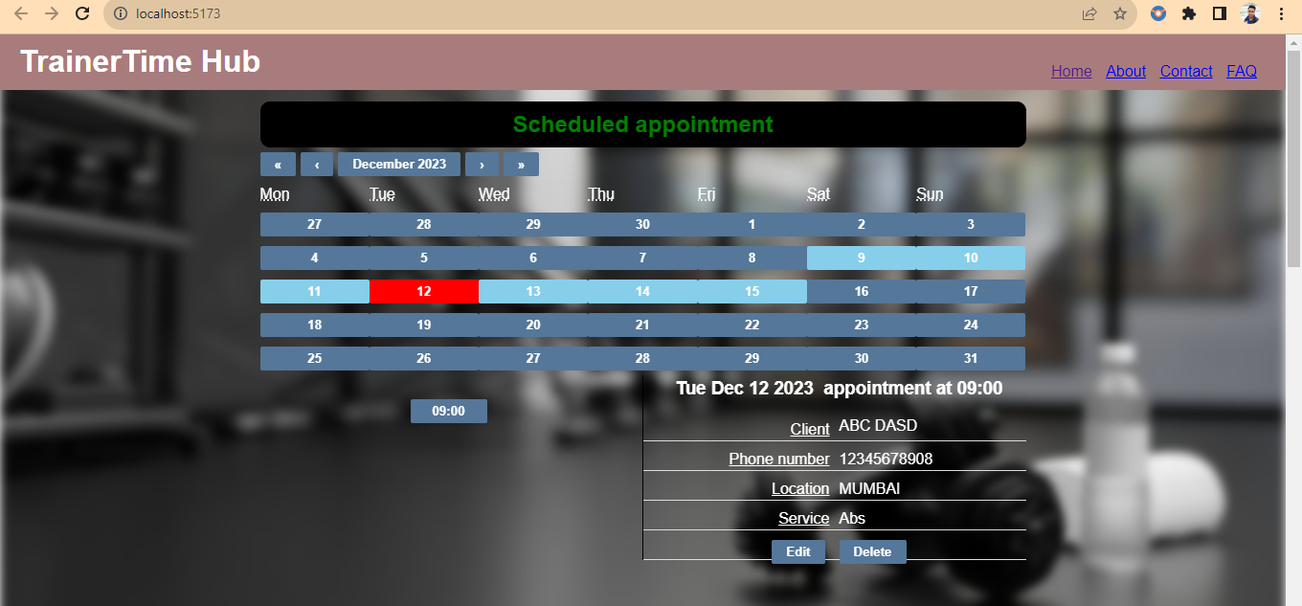

Step 2 :- There is edit and delete button given below the detail view which allow trainer to edit and delete the data.

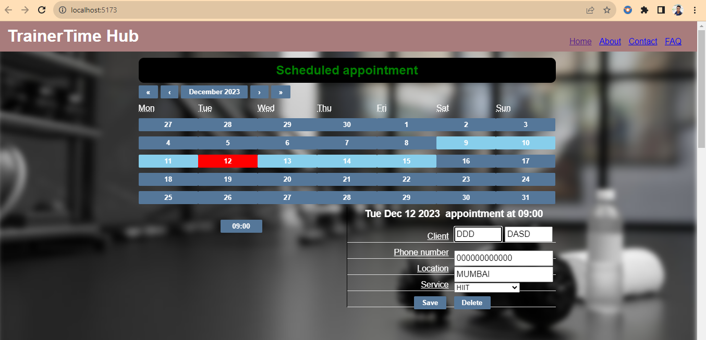

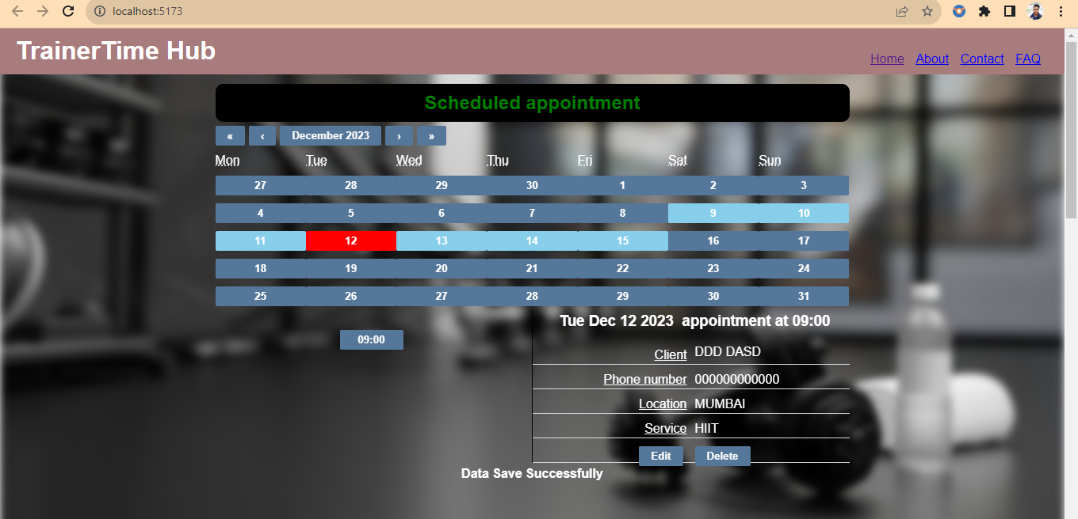

1. DELETE Appointment:- there is delete button given below the detail view which allow trainer to delete the data. When trainer click on delete button that slot will be deleted and notification will be diaplayed “data deleted successfully”

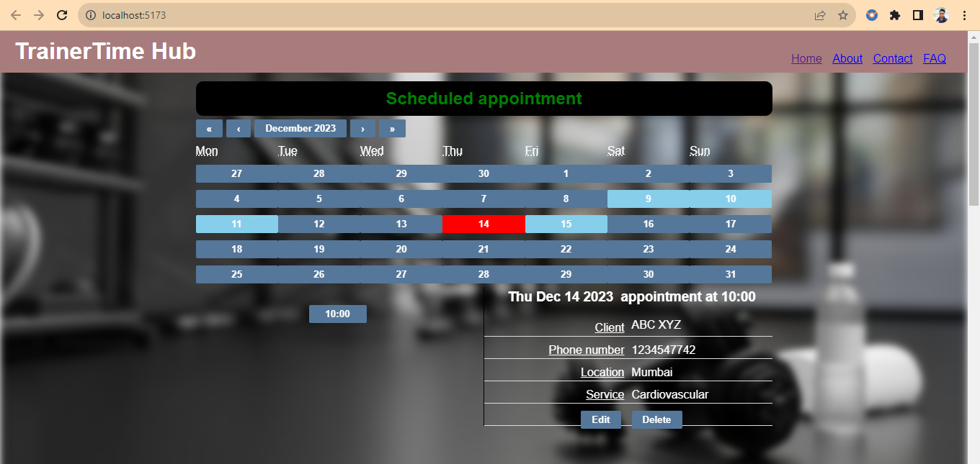

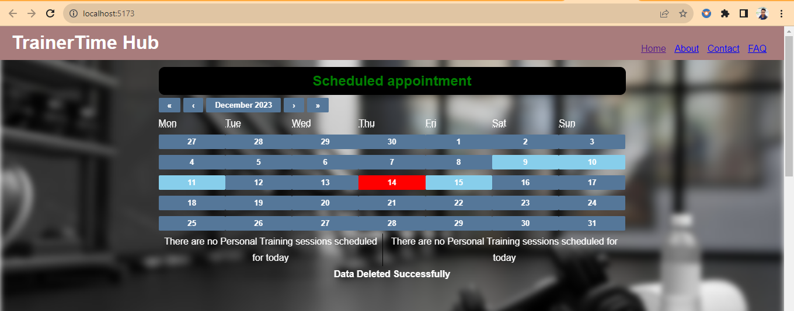

5. **Appointments Field:-** scheduled appointment field displays a calendar where scheduled appointments date is highlighted with “ light blue colour” trainer can click on light blue colour highlighted date and see the scheduled appointment date and time and details of client.

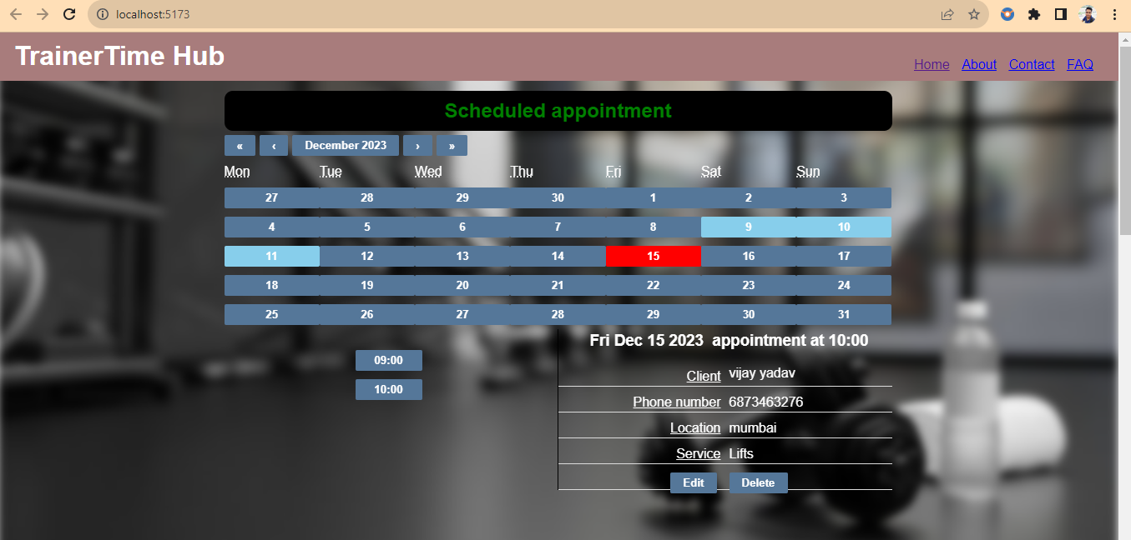

**Conclusion**:- This is a basic application built using react.js to scheduled appointment of client for trainers, where trainer can add ,edit and delete the schedule appointment of client.